REPORT ON DATA MATRIX DETECTION.

Images containing data matrix are collected and are fed into the matrix detector program. For which the following data is observed.

Total number of JPEG files: 37

Number of files where area is detected: 25

Out of these 35, 22 instances had returned a code, while others returned an empty string.

true positives = 19

false positives = 0

true negatives =

false negatives = 6 + 12

The model is able to detect the codes from the following group of images.

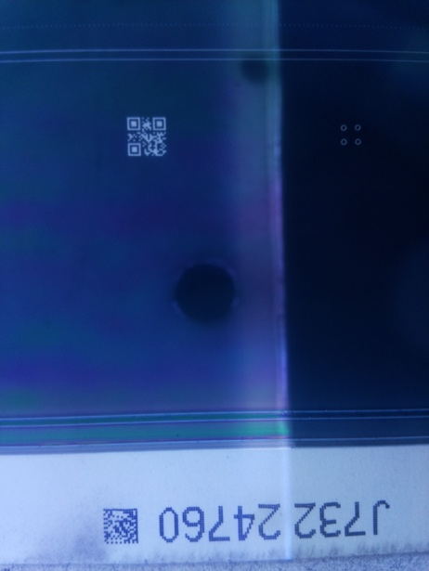

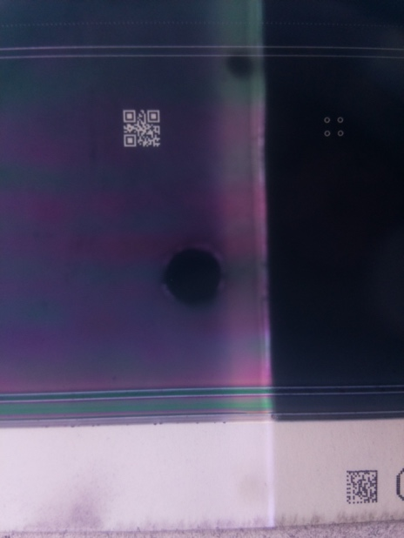

The model could not detect codes from the following images

The undetected data matrices like the following

The problem with the decoding of the data matrix is that the code is distorted in the image or unclear matrix code. When tested using an online decoder, the data matrix could not be decoded.

Try threshold, next eroded/dilute, next try gray.